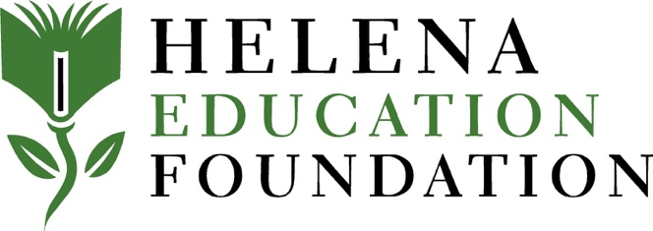

The Helena Education Foundation invites educators of the Helena School District #1 (HSD1) to submit grant applications to our mini grant program for projects totaling $500 or less. As with our Great Ideas Grants program, project ideas must be new, and execution of the project cannot begin until you are notified of your grant award. All purchases must be made through, and according to HSD1 procedures; we encourage shopping locally when possible. Please complete the following application, including budget and project timeline and email it to hef@mt.net in MSWORD format - don’t worry if the formatting changes as a result. Note: your school principal must sign off on your grant request (electronic signature is acceptable). Due dates for grants submission are: September 28; December 7; February 1; and March 29. Grants due by September 28 may be submitted prior to the start of the school year.
Helena Education Foundation
Spark Grants
Application

Project Title: Amount requested:
(max = $500)
Applicant Name:

School Name:

Grade Level: Estimated # of students to be served:

Principal Signature (electronic signature acceptable):

Summary Grant Description:

Briefly describe your project and how you would use the funds (include project timeline):

How will the project improve student experience/opportunities?

Budget
(expand table if needed

Item | Qty | Unit Cost | Shipping | Total Cost
 |  |  | Total

