Helena Education Foundation
HPS District Employee Payroll Deduction Form
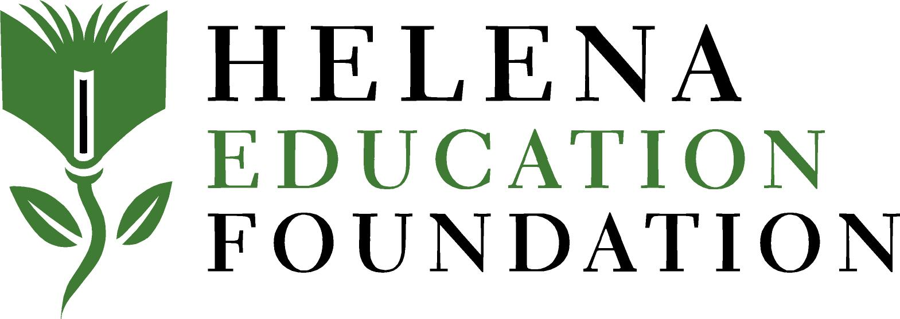

Thank you for utilizing payroll deduct to support the Helena Education Foundation; we are truly grateful for your support of our programs!

Please complete the payroll deduction form on the Employee Portal, or complete this form and return it to the payroll department at Lincoln Center via interoffice mail, or email it to Angela Ford (aford@helenaschools.org) or Brooke Mahoney (bmahoney@helenaschools.org).

About You:

Name: __________________________________________ Last 4 digits of SSN#___________________

Address: _____________________________________________________________________________

City, State, Zip: _______________________________________________________________________

Email Address: ________________________________________Phone: __________________________

School: _____________________________________Position: _________________________________

Gift Amount:

Please check or write in how much you would like to donate per pay period

______$5 _______$10 _______$15 _______$20 ________ $25_______ $50 _________Other

Number of Pay Periods:

Please check or write in how many pay periods you would like processed with your payroll deduction

______1 ______10 ______12 (1 month is a one-time gift)

Other:

Start date: __________________________

Signature: _______________________________________________________________________

Thank you for all you do to help Helena Public Schools thrive!

Helena Education Foundation • P.O. Box 792 • Helena, MT 56924 • 406.443.2545 • info@hefmt.org • www.hefmt.org

